To Finish…  Rich Chocolate Brownie served warm with Chocolate Sauce & Alburgh Vanilla Ice Cream £6.50  Eton Mess; Mixed Berry, Meringue, Chantilly Cream & Coulis £6  Sticky Toffee Pudding with Toffee Sauce & Vanilla Ice Cream £6.50  Cherry Bakewell Tart served with Vanilla Ice Cream £6.50  Cheese & Biscuits; Cornish Brie, Cheddar & Blue Stilton with Celery, Apple & Barn Acre Plum Chutney £7.50  Alburgh Ice creams & Sorbets Gf £1.50 scoop  Vanilla Sorbets;  White Chocolate Lemon  Belgian Chocolate Strawberry & Mint  Strawberry Raspberry  Hot Drinks…  Americano £2.00 Baileys Latte £4.95  Latte £2.20 Gingerbread Rum  Cappuccino £2.20 Latte £4.95  Hot Chocolate £2.50 Mocha £2.50 Liqueur Coffee £4.95  Espresso single £2.00 double £2.60 Ask about our fruit tea selection  Pot of Tea £2.00  Luxury Hot Chocolate Orange; whipped cream, marshmallows & Cointreau liqueur£4.95 Luxury Hot Chocolate; whipped cream and marshmallow £3.00  (add a syrup; gingerbread, caramel, vanilla, hazelnut, mint chocolate £0.55) |  |  |  |  |  |  |  |  |  | 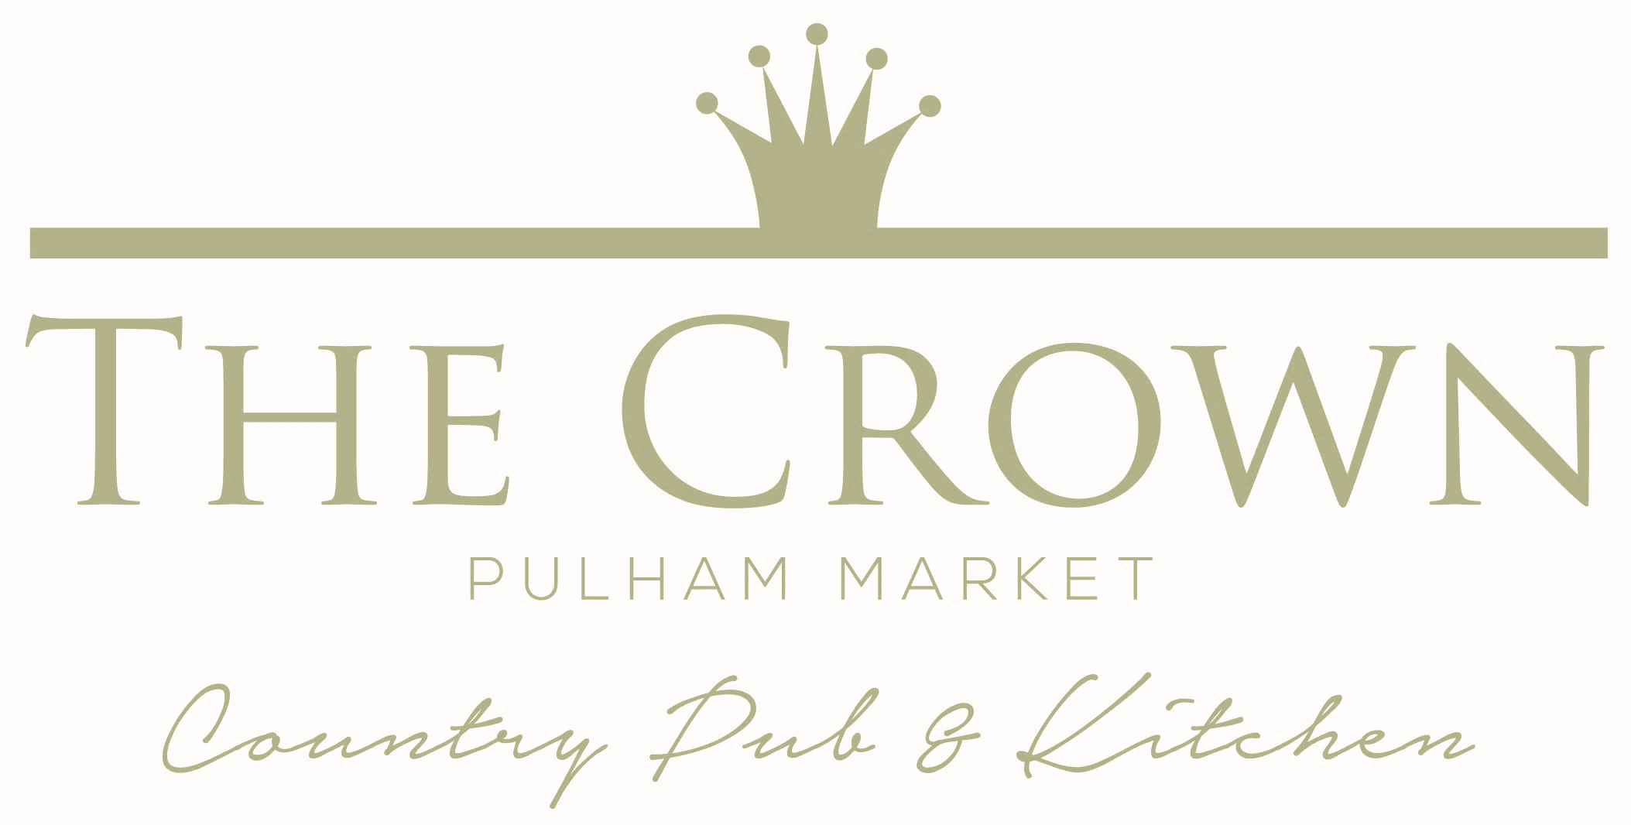  Food Menu  ____________________________________  ‘Where possible, we source everything from our menu locally, ensuring your food is full of the freshest and tastiest ingredients. Fruit and vegetables come in all shapes and sizes and every single one of them, served fresh tastes perfect- that’s what counts.’ ____________________________________  If you have any dietary requirements or special requests please don’t hesitate to discuss it with a member of the team who will be very happy to help.  For our full range of drinks please see our ‘drinks section’ on our website –  www.thecrowninn-pulham.co.uk
Ciabattas...  Available 12-2:30pm - All Served with Fries  Hot Pork Ciabatta with Apple Sauce £7  Crispy Breaded Chicken with Tomato, Baby Gem Lettuce & Mayonnaise £7  (V) Goats Cheese & Beetroot £6.50  Homemade Breaded Fish Finger with Tartar £6.50  Light Bites...  Loaded Potato Skins; Topped with Cheddar, Smoked Bacon & Sour Cream Dip £4.00 Gf  Smoked Haddock Fishcake served with Poached Hen’s Egg, House Salad & Tartare Sauce £9  Cajun Spiced Halloumi Fries with Sweet Chilli Mayo Gf £4  To Start...  (V) Goats Cheese & Beetroot Mousse with Honey, Poppy Seeds, Norfolk Leaves & Granary Toast  Gf* £6.50  Chilli, Chorizo & Garlic King Prawns on Toasted Ciabatta £7  Cheesy Leek & Parma Ham Croquettes with Homemade Tomato Chutney £6.50  (V) Locally Grown Crown Prince Squash & Golden Beetroot Tart topped with Brie, Toasted Seeds & Root Vegetables Crisps £5.50  (V) Courgette & Falafel Fritters with Lemon Crème Fraiche Gf £6  (V)Garlic * Rosemary Studded Camembert with Toasted Soldiers Gf* £6.50 |  |  |  |  |  |  |  |  | Main Course…  Creamy Smoked Haddock Chowder with Leeks, Sweetcorn & New Potatoes, Crusty Bread & Salted Butter  Small £7 Large £13  Crispy Belly of Norfolk Pork with Fondant Potato, Tender Stem Broccoli, Leeks, Peas & Spinach with a Thyme & Red Wine Gravy £14  Pan Fried Scottish Salmon Fillet on a Medley of New Potatoes, Chorizo, Lemon & Peas £14  Homemade Steak Burger topped with Cheddar & Bacon served with Pink Onions, Beef Tomato, Baby Gem and Homemade Tomato Chutney with Fries Gf* £13  (V) Lightly Spiced Sweet Potato & British Garden Vegetable Hash with Poached Hens Egg & Rich Tomato & Harissa Sauce Gf £11  Breaded Wholetail Scampi with Chunky Chips, Tartare, Torched Lemon & Garden Peas £13  15 Hour Slow Cooked Topside of Norfolk Beef with Crisp Bubble & Squeak Cake, Baby Vegetables, Watercress & Proper Pub Gravy Gf* £13  (V)Creamy Wild Mushroom, Leek & Spinach Linguine with Toasted Pine nuts £11  Add Chicken £2  Sides...  (V)Crushed New Potatoes £2 (V)Bread Soldiers £2  (V)Fries £2 (V)Coleslaw £2  Chunky Chips £2.50  (V)Garden Salad £2.50  (V) Vegetarian Gf Gluten Free  Gf* Gluten Free Adaptable

